Creating Club Memberships & Pricing

1. So now it’s just time to add the detail to the Membership Type.
From the main dashboard, go to Membership Types

Select the Shopping Cart icon next to the Membership Type you want to complete
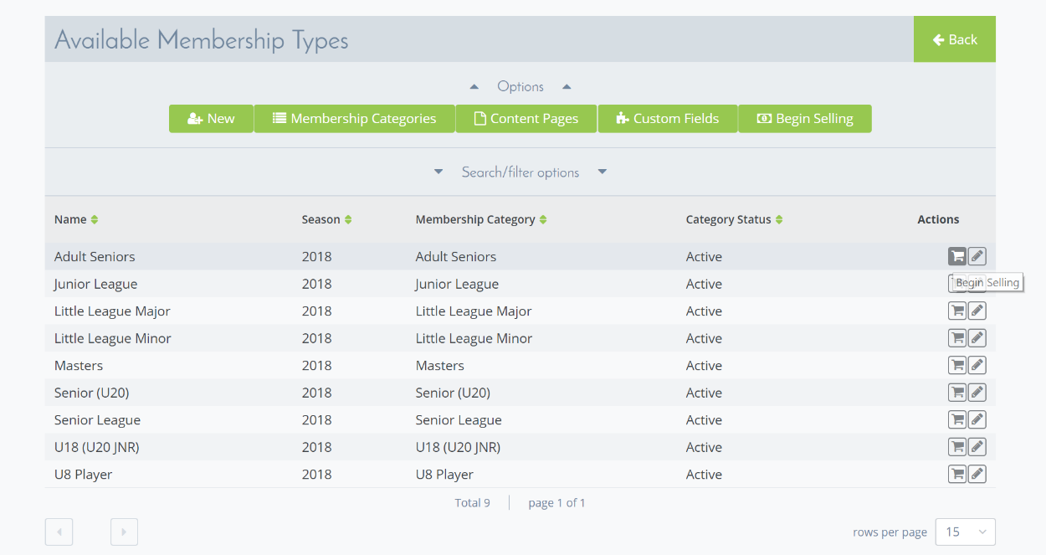

Add New Membership Package
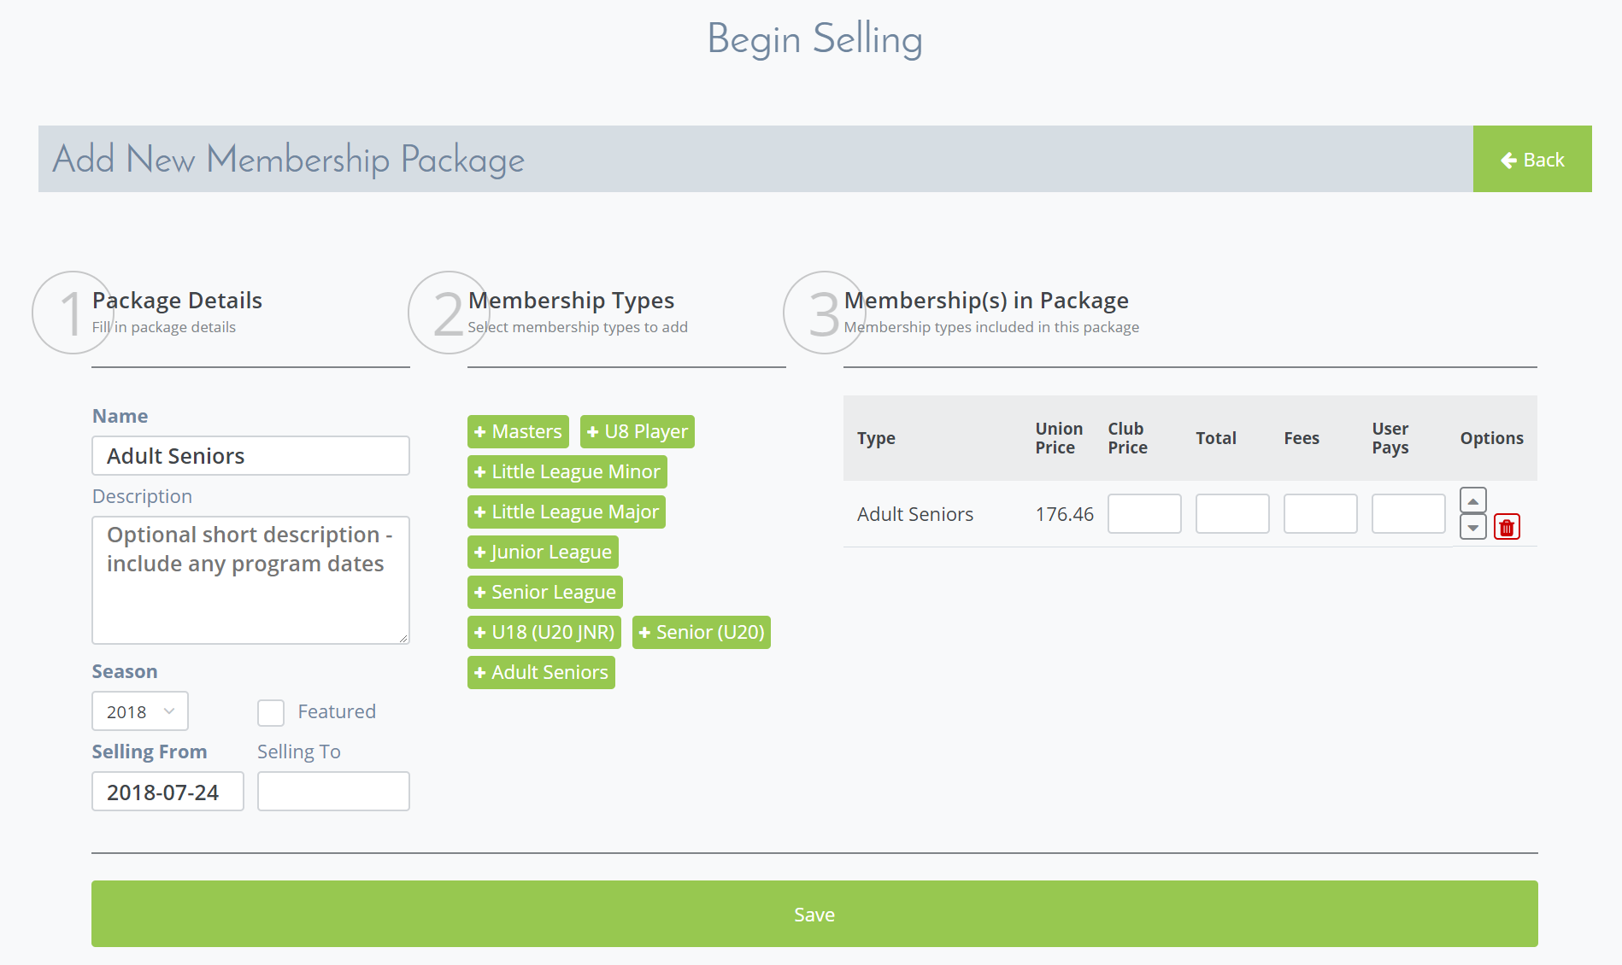
Complete Step 1;
- complete the description
- selling to date – which us the last date that you would like this product to be available
Step 2;
- Generally leave as is
Step 3;
- Add your Club fee in the Club Price section
- Hit save
You can then review all published Memberships on the Begin Selling page;
