MANAGING YOUR GROUP
Sports Club HQ is an invite only system that is designed for the specific purpose of keeping players and families connected throughout the season. The site protects the user and all of the information shared. Most people would be familiar with the idea of a social networking site but this one is different – only people in your team/group can see the informationcv that is shared on Sports Club HQ. It is a private social network for your team and club only!
Your group in Sports Club HQ is the place to communicate all the training and game details, share the photos and videos from the weekend games and send messages to members of the group for immediate notifications (eg. training is off!) You can also distribute any important club updates through here as well.
GETTING STARTED
Once your group has been created you will be sent an email inviting you to join the group (and register to the site). Once you have completed that part you will be appointed the group admin/leader of the group.
Your first job is to collect the details of all people who will want or need to be involved with the communications of the team. This could be parents, grandparents, aunties, uncles, guardians, etc. It will be up to your discretion as to who should have access to your group, remembering that each group is private, and people can only access by being invited to join (you can also remove members at any stage). We have provided you with an info flyer to circulate to the parents to inform them of the Sports Club HQ group and what it’s about. You should have also been provided with a ‘Group User Details’ print out, which is what you can use to collect all of the names and email addresses required to invite users into the group.
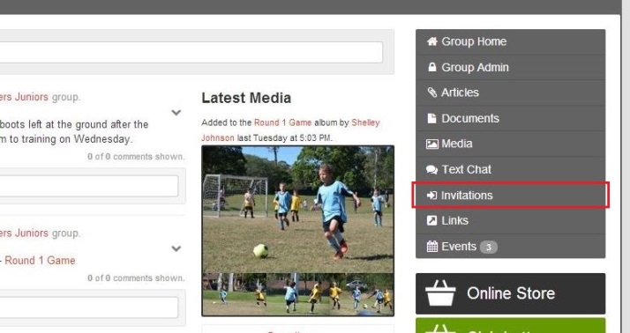
Inviting Users
Inviting users to your group is easy. Once logged into the site, navigate your way to the Group by going the “Groups” page. In the right hand side menu, select Invitations.
Then simply complete the form, entering the name and email address and hit ‘send invitation’. This sends the invitation via email to the intended recipient.

GETTING AROUND THE SITE
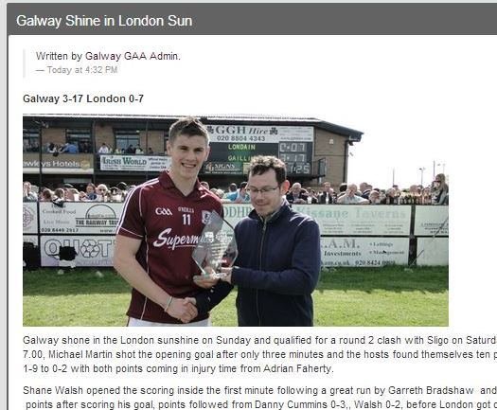
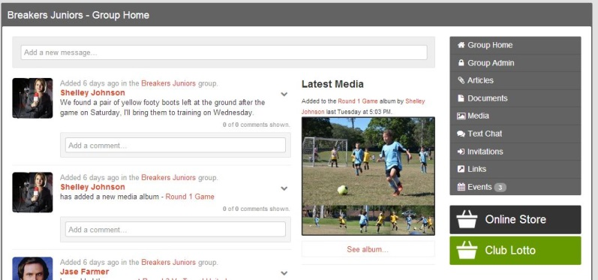
Home Page/Activity Feed
The home page is the first page that you land on after logging in to the site. On this page you can see the latest activity from the groups that you are connected to. At the very top right of the page, next to your thumbnail image, you can access your profile management area, and access your Groups by clicking on the Groups icon.
Articles (like a private Blog)
The articles feature allows you to send and read the latest news, articles and match reports from the Club, Groups and Teams within the club. To view an article, navigate to the group, select Articles from the menu; then simply click on any article title that you wish to read. When reading you will also notice that you can comment on any article at the bottom of the page. To navigate back to the main Articles page, hit the Articles button on the right hand side menu.
To create and send a new article, simply hit the ‘new article’ button and then enter the title and content where provided.
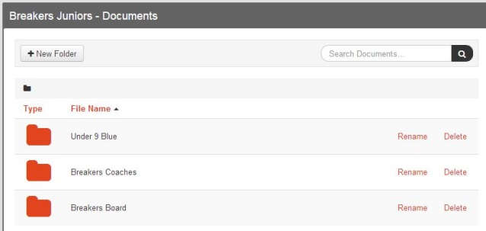
Documents
The documents section is a space used to store documents for users to download. To find a document you may be looking for, simply search through the available folders.
If you see a Document you wish to download, click on the title of the document, a pop-up box will drop down and ask you to confirm that you want to download that document. When you hit ‘ok’ the system will download the file to your “downloads” section on your computer.
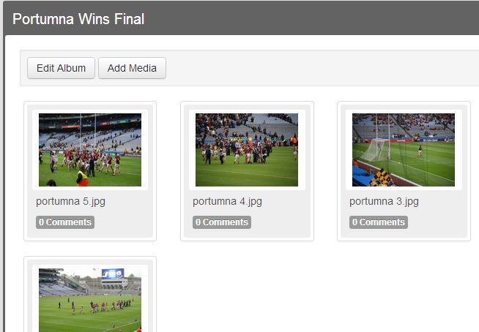
Media
To access the Media section click on the Media button on the right hand side menu. This will take you to the Group’s Media section. To view an album, you click on any album cover, this will then show you the contents of the album. You can hit any image and that will open all images in a slideshow. There are two options to scroll through the slideshow;
1) Simply click anywhere in the image box and it will move to the next image, or
2) Click on the thumbnails located at the bottom of the slideshow. You will also note that can comment on any individual photo or video as well.
Text Chat
The text chat feature is a live group chat room that allows users to meet together in there. To open the chat room you click on the Text Chat button in the right hand side menu. Once it opens, the system will automatically announce your arrival in the room. You can see who else is in the room by looking in the “Online Members” section. To post a message to the room, type your message in the white column where the words read, "write a message", then hit send. Your message will be posted to the wall for all to see. To leave the chat room, simply close the window.
Links
The links section contains a list of helpful websites that have been sourced by the Group Organiser to make life easier for the members. To view a link, you click on the title of the link, or the URL itself. This will then open the webpage in a separate tab on your internet browser.
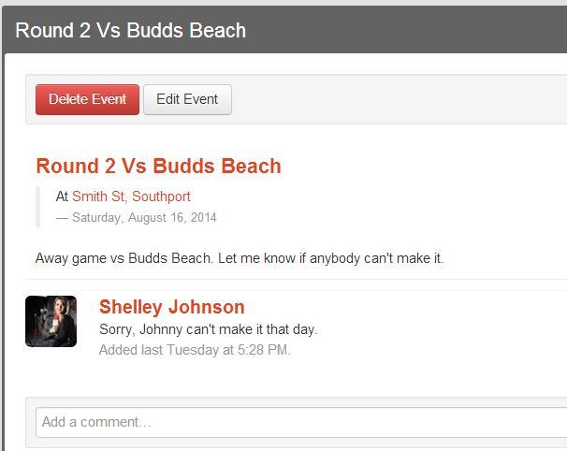
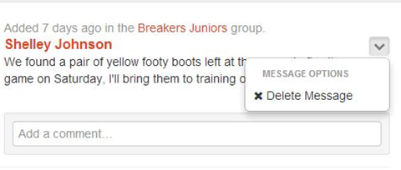
Events
The events section is where all fixtures, club and team events should be posted. To view an event, simply click on the Events button in the RHS menu, this will show you a list of all upcoming events. To view a specific event, click on the event title. This will then show you the details of that event, and you can make a comment on that event, for instance, to confirm your attendance.
Comments
Anywhere you see the words ‘add a comment’, you are able to type something and publish it. Place your cursor into the text box that says ‘add a comment’ and then begin to type. You will see your words appear on the screen as you are typing. Once you have finished typing, press the button that says ‘add comment’. You will then see your message on the screen.
You can also delete your comment be pressing the drop down arrow and then selecting ‘delete comment’ as shown here in this image.
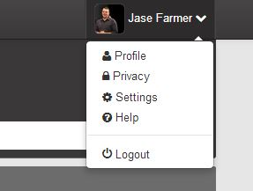
Managing Your Profile
Select your name at the top right of the screen, click on the arrow and a drop down will appear. Select ‘profile’ from the drop down list. You will then be taken to the ‘edit profile’ page. Here, you can edit your first and last name, email address, user name and other personal details.
You can also change your profile photo. Click on ‘change’, this will open a pop-up window to allow you to find the image you want to use for your picture. Once you locate the picture, double-click on it and it will begin to upload. In a few moments, you will see your new profile image appear. Before you leave the page, make sure your press ‘save profile’ to save any changes you have made.

Helpful Resources
You should have received the following documents:
- Information Flyer for all Members
- How to Manage Your Group
For any further ongoing assistance, to download the documents above, or view how to videos; go to http://www.sportsclubhq.com/support.html for more.

